TPC Analytics Technical Manual

# Introduction:

TPC Analytics is a combination of software and hardware that allows a performance coach (strength and conditioning coach) to measure an isometric test (leg extension) or a CMJ jump to be measured and do asymmetry analysis over time for any given athlete.

The following are several screen shots of the software:

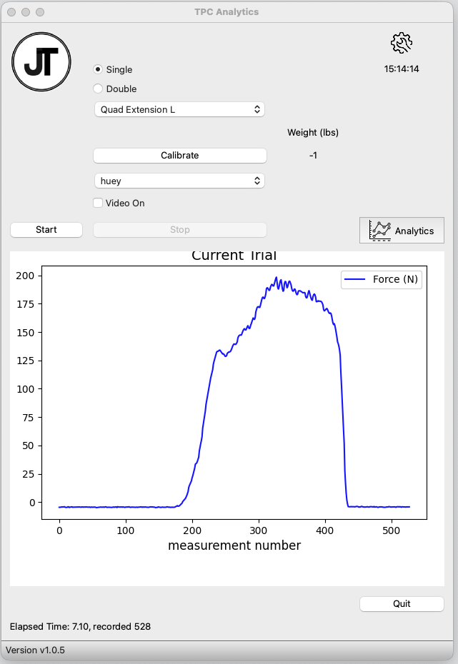

Initial Data Collection Screen Sample

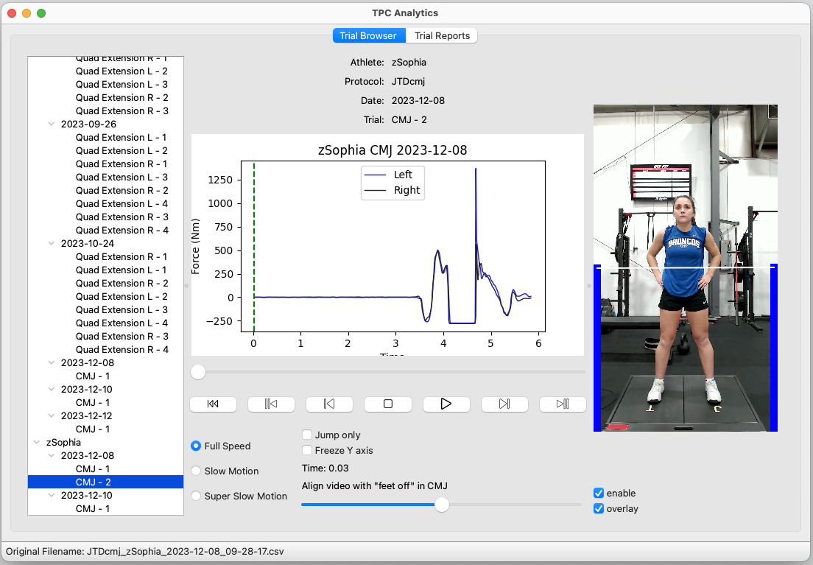

CMJ Analysis – start of trial

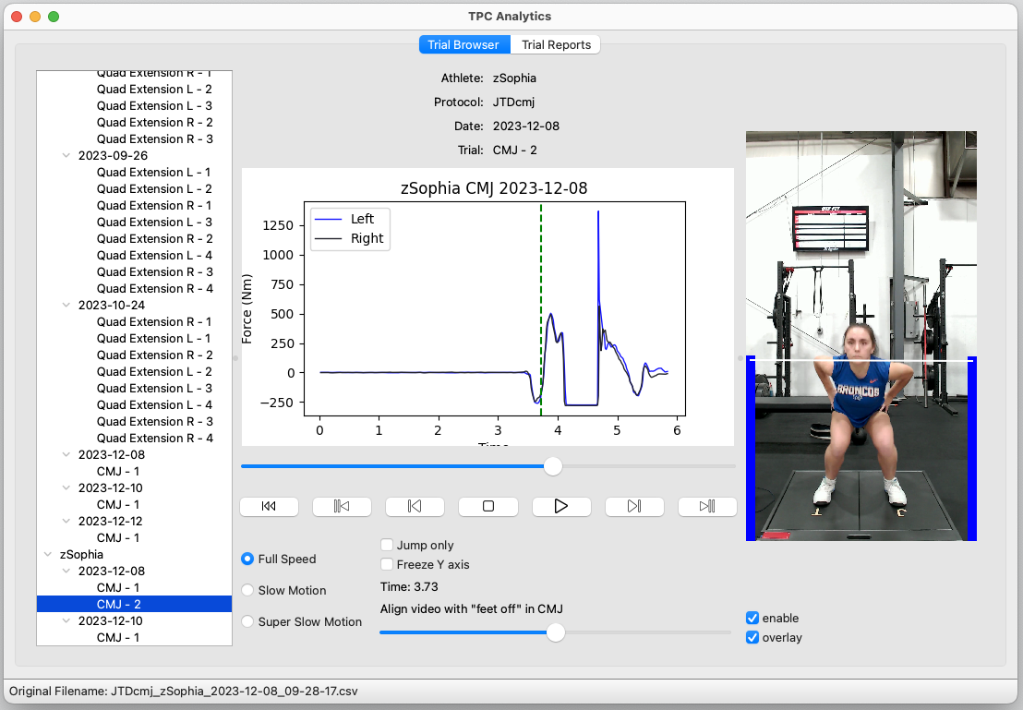

CMJ Analysis – in jump

x

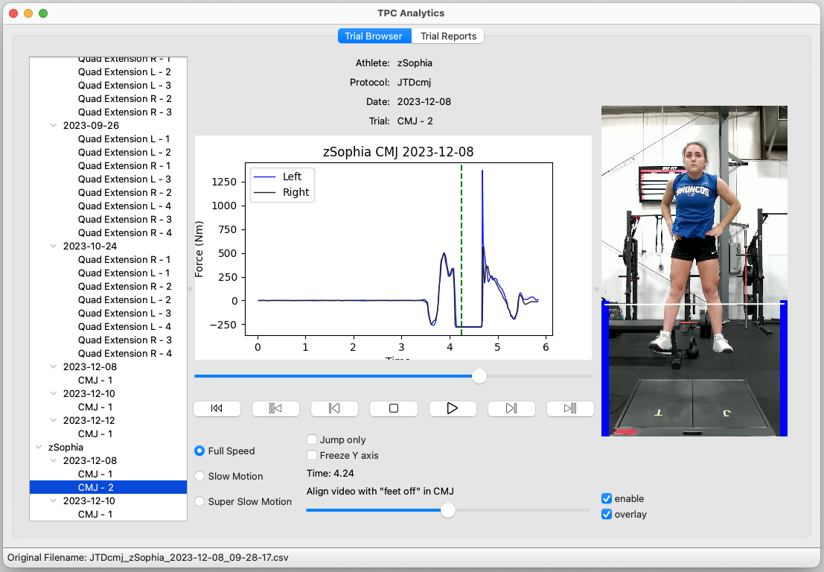

CMJ Analysis – in jump

# Usage and Operations Videos

Installation Video

Usage Video

Structure of Data on Disk Video

Software Maintenance Video

Micro Controller video

Jump Plate Video – construction

# Overview Steps

If you are interested in utilizing the TCP Analytics system, I would approach the project in the following way:

1. Download software and get familiar with it and the reports it provides.
2. Purchase the BOM pieces necessary to do the ISO Leg Extension which is the easiest setup. This should include the breadboard pieces listed as optional. Optionally you could buy all the Micro controller parts up front as well.
3. Validate the breadboard setup works with the single Sensor.
4. Make production (soldered and in case) version Micro Controller
5. Lastly, move on to buying the necessary pieces and building the Force Plates

# Software Required

## TPC Analytics

This software is downloaded from GitHub and is part of the project at this location: <https://github.com/boiseskibum/TPC_Analytics>

Installation instructions:

1. On MacOS open a terminal window (use search to find Terminal). It should look something like this: 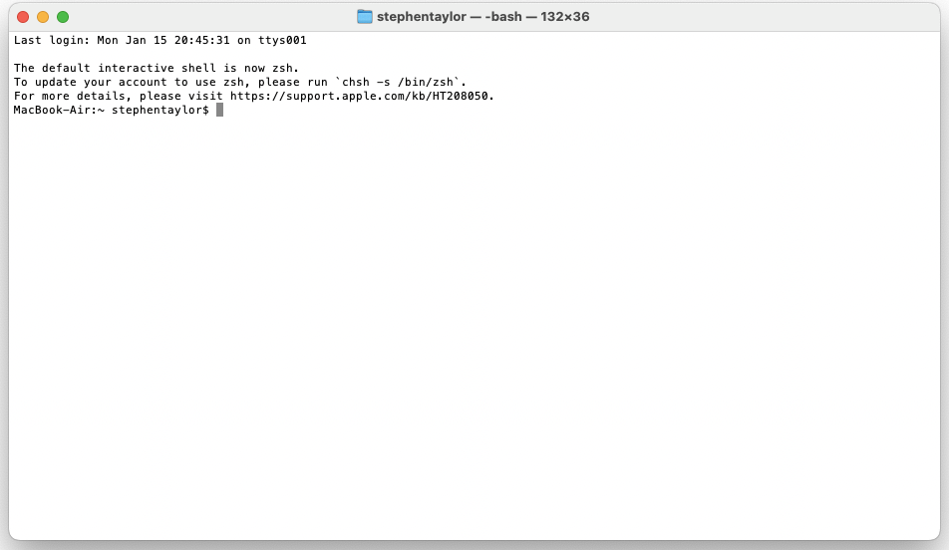
2. Cut-n-paste the following commands which download the files, change permissions and lastly runs the setup script:
   1. curl -o TPC_macOS_setup.sh <https://raw.githubusercontent.com/boiseskibum/TPC_Analytics/master/TPC_macOS_setup.sh>
   2. chmod +x TPC_macOS_setup.sh
   3. ./TPC_macOS_setup.sh

Note:

1. Upon executing the *./TPC_macOS_setup.sh* it is likely to tell you to install Python. Please do so as requested. As of the time of this document, the supported version of Python is 3.11. After installing Python, rerun the *./TPC_macOS_setup.sh*
2. After the steps above are completed there should be a “TPC Analytics” folder created in your documents folder. This will contain an Icon to start the application as will your Desktop. It is understood that this isn’t the standard place to put these icons but it turned out that the applications folder had challenges that were not overcome.

## TPC Analytics Micro Controller

This software is only needed one time when the micro controller(s) are built (see below). The purpose of this is to load the program onto the Micro Controller that reads the sensors and sends the data to the laptop.

To download Arduino, use the official site <https://www.arduino.cc/en/software>. It has instructions but I also utilized documentation on the SparkFun site: [Installing Arduino IDE - SparkFun Learn](https://learn.sparkfun.com/tutorials/installing-arduino-ide)

The software that you will need to download is located here

# Hardware Required

There are 4 hardware components that make up the system.

1. The micro controller which translates the signal from the load cells to the computer and 1 of two load cell options
2. ISO leg extension load cell
3. Force Plates (jump plates)
4. Apple Laptop – Apple Silicon M1, M2,… has been verified to work. For Windows users see FAQ below.

Excluding the laptop the BOM to build 2 micro controllers, ISO Leg Extension, and Jump plates is a ~$675. Here is the link to the BOM

## Micro Controller

Whether or not you utilize the ISO Leg Extension or the Jump Plates you will need a Micro Controller. See the BOM for details of what is required but essentially you will need to have the following skills to build this:

1. Soldering of electronic circuits, cut and bend some wires.
2. Downloading the micro controller code (already written) for the Arduino IDE. Utilize the IDE to download the code onto the controller. No coding is necessary for this.

Most people with a little effort can utilize YouTube to figure both things out.

Here is the wiring diagram (my apologies for those that have issues with colors). If you are making the ISO Extension setup you will not need the second Sparkfun HX711 which is labeled “Right Jump Plate” show below. Just leave it off

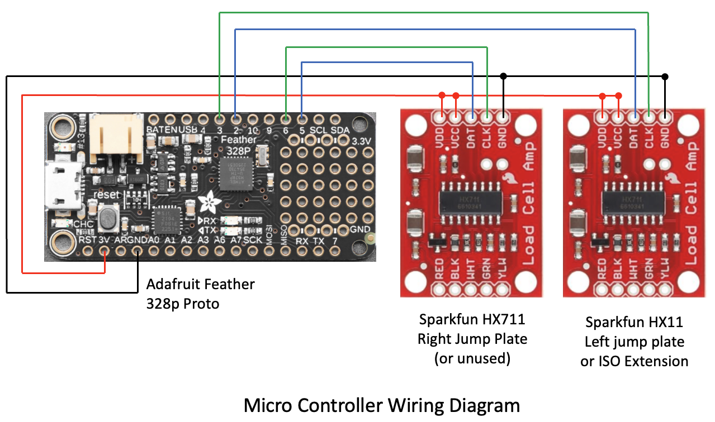

It is your choice if you want to just solder it all together and see if it works but I took the time to do a partial build where the legs were soldered onto the micro controller and the Sparkfun HX711 Load Cell amplifiers. I then validated that everything worked properly on the breadboard setup below. It looks messy because jumpers seem to go everywhere but in reality, it is just the wiring diagram shown above. I strongly recommend doing this step.

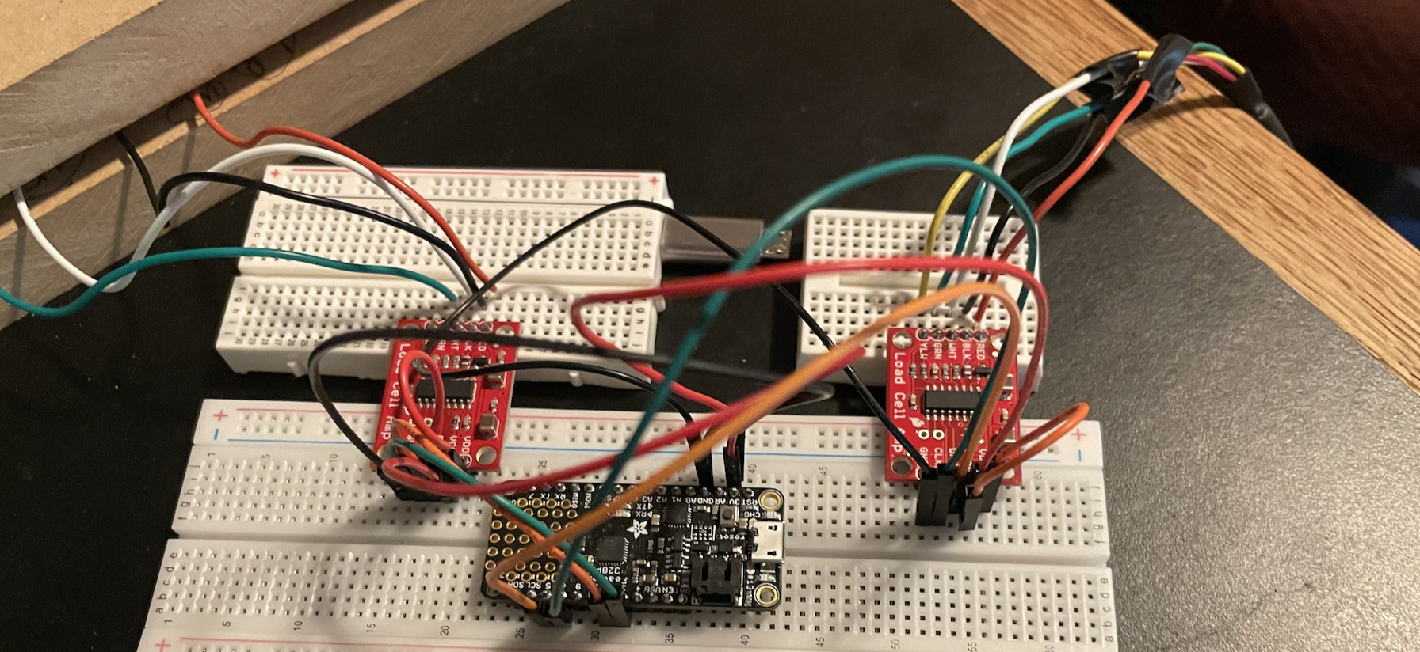

Breadboard testing setup

Note for the photo above, on the left is the Jump Plate setup with 4 wires. On the right is the ISO leg Extension load cell which has 5 wires. For exact wiring see the wiring diagram.

The following link is a video on how to download the code to the controller

## ISO Testing Load Cell

This is a load cell (plus screw eyes on BOM). It has 5 wires that connect to the micro controller.

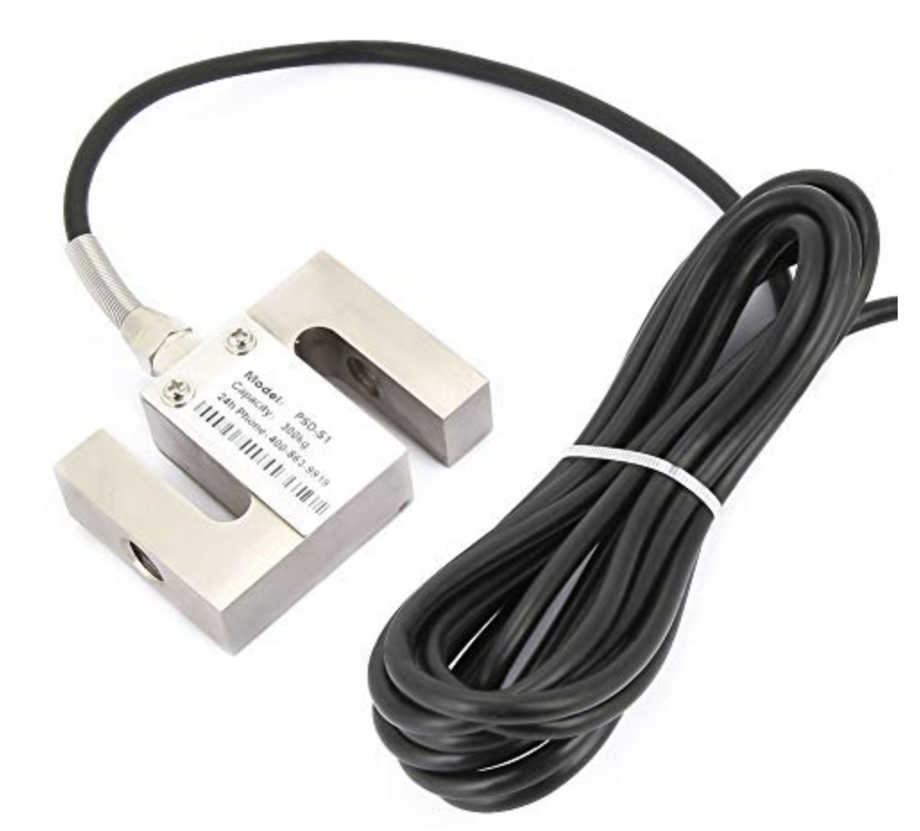 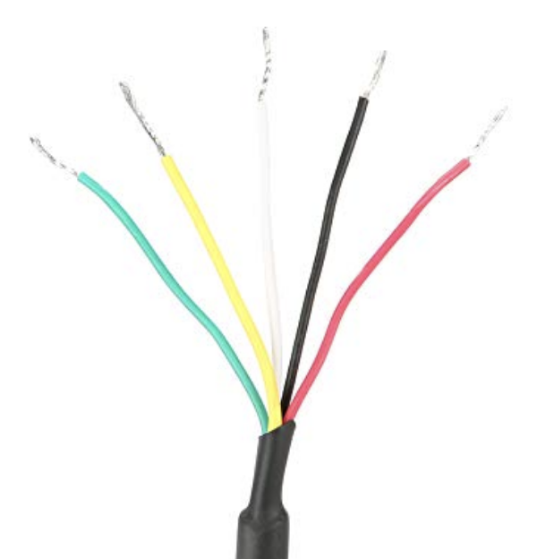 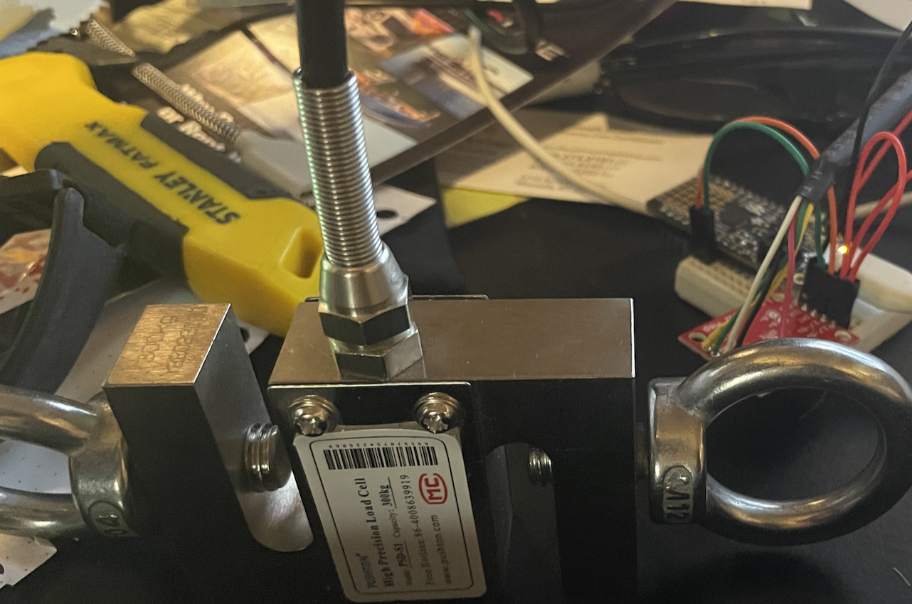

Completed ISO Leg Extension setup (Load Cell, Microcontroller, USB cable, ropes/carabiners to hold the load. The ropes were later replace with ½” nylon straps of length needed.

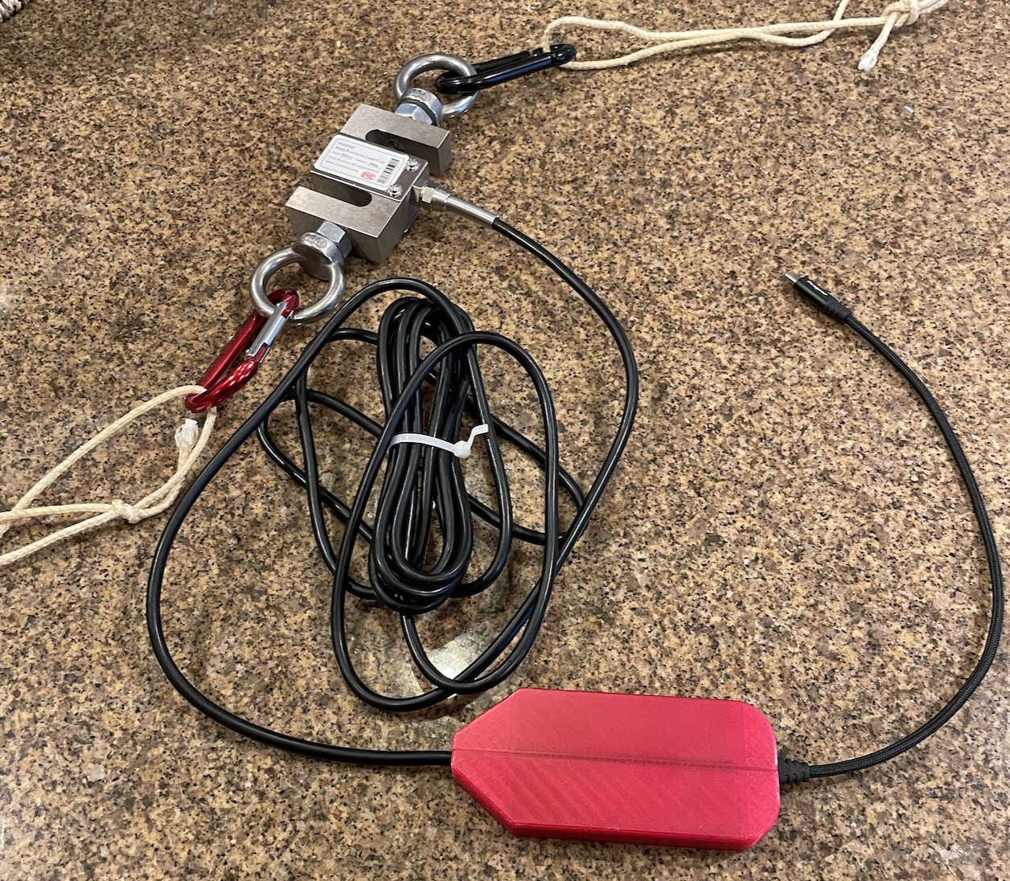

The ISO Leg extension device is easy to build because once you have a micro controller, it is just a case of soldering on the 5 wires to the Micro Controller unit. The wires even go to exact the color specified on the SparkFun HX711 load cell amplifier. Hence, I am not producing a wiring diagram for that.

Cases: The red plastic case in the photos are 3D printed. The 3MK file is the design of the case that you can send to a shop that produces 3D prints. If you have a friend that has a 3D printer they can do this also. The cases should be printed with PETG at 20% infill. I utilized .2 line width and the wall thickness I set at 4 rows. Notice that offsets jump plates will need to be 3D printed as well. See do1wn below for instructions on them.

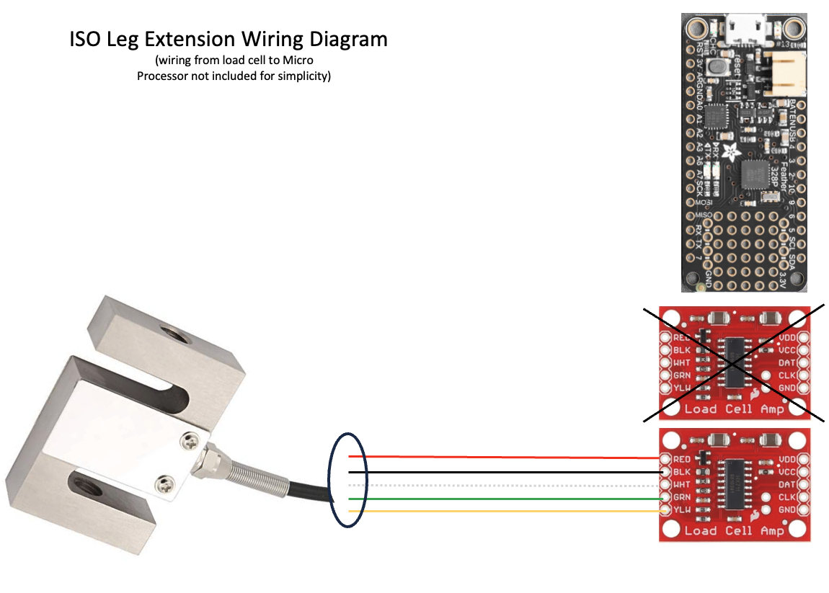

## Force Plates

Building the Force Plates is more complex that the ISO Leg Extension. This build will require somebody with woodworking skills and pragmatic thinking. The following documentation is sufficient for a reasonably skilled wood worker to build plates that work but by no means is it step by step. Warning, if you do not know how to utilize power tools safely, please find somebody who does.

Finished force plates:

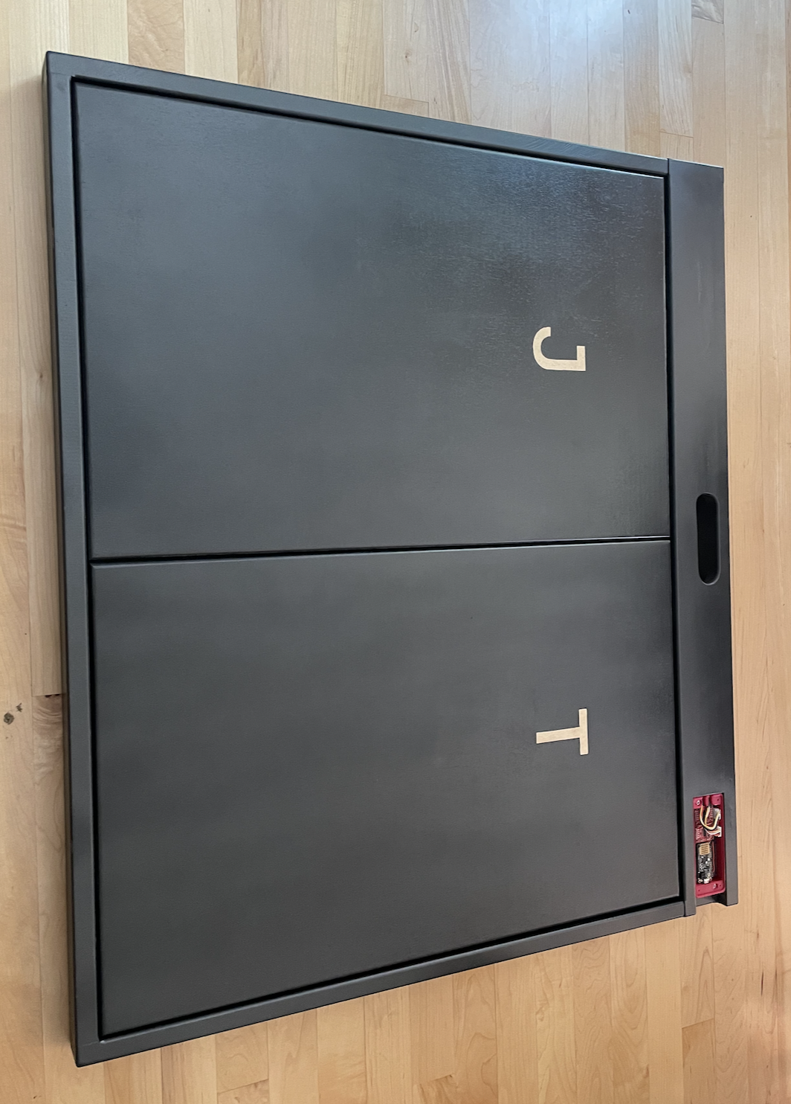

Finished plates without the plates attached:

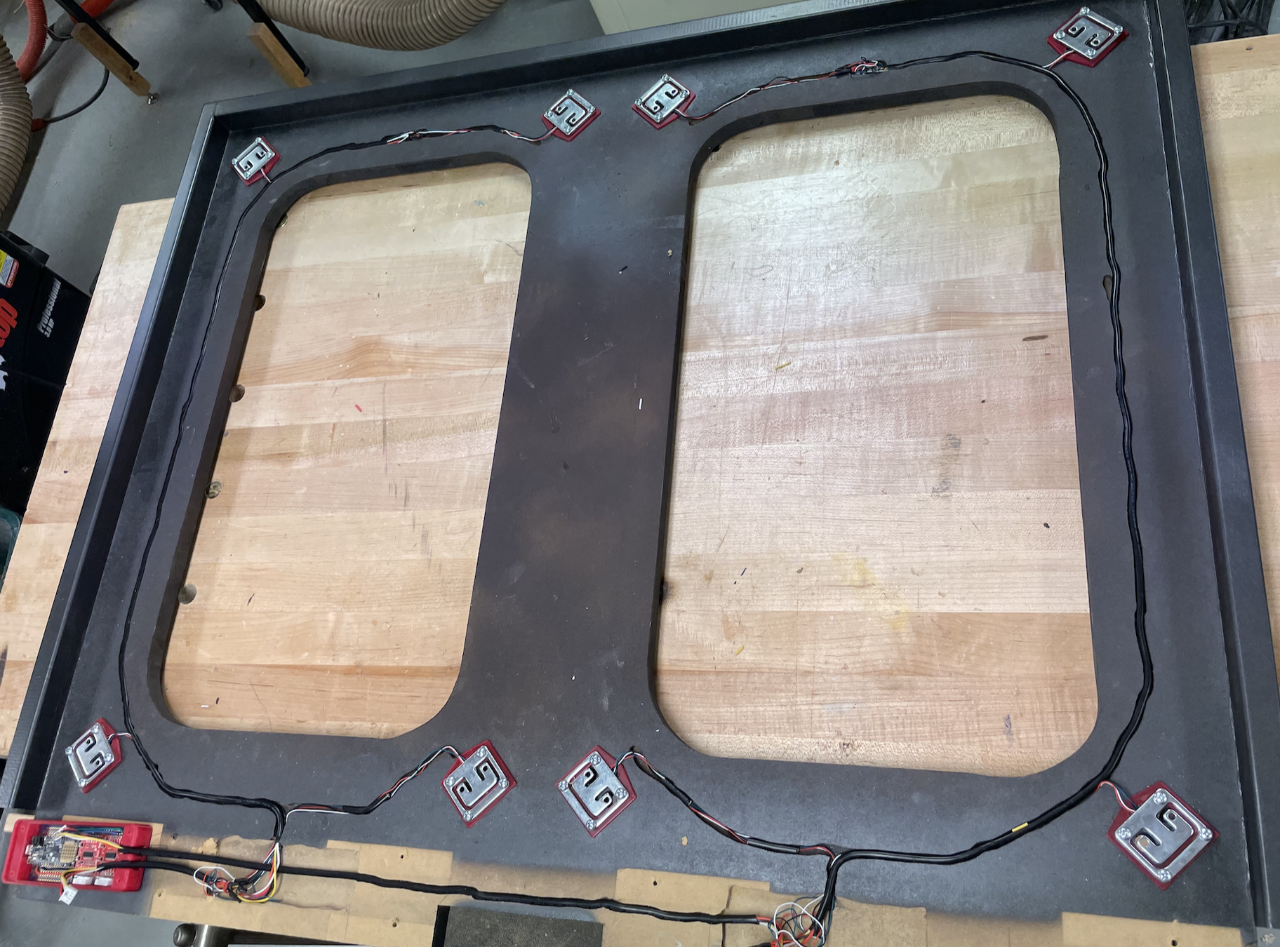

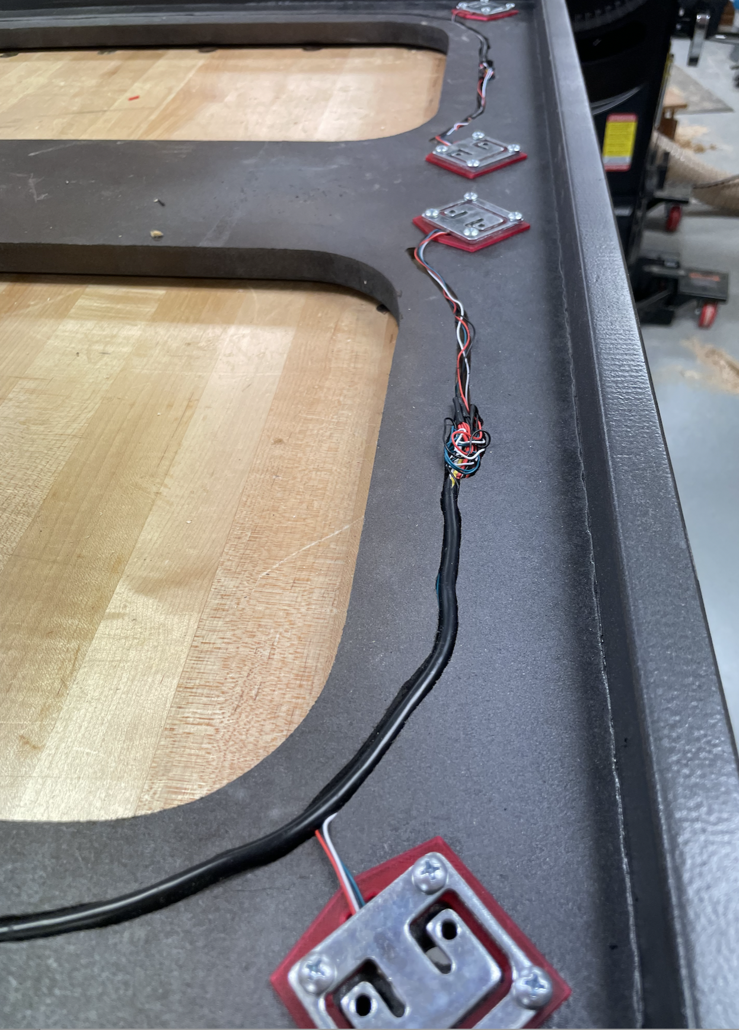 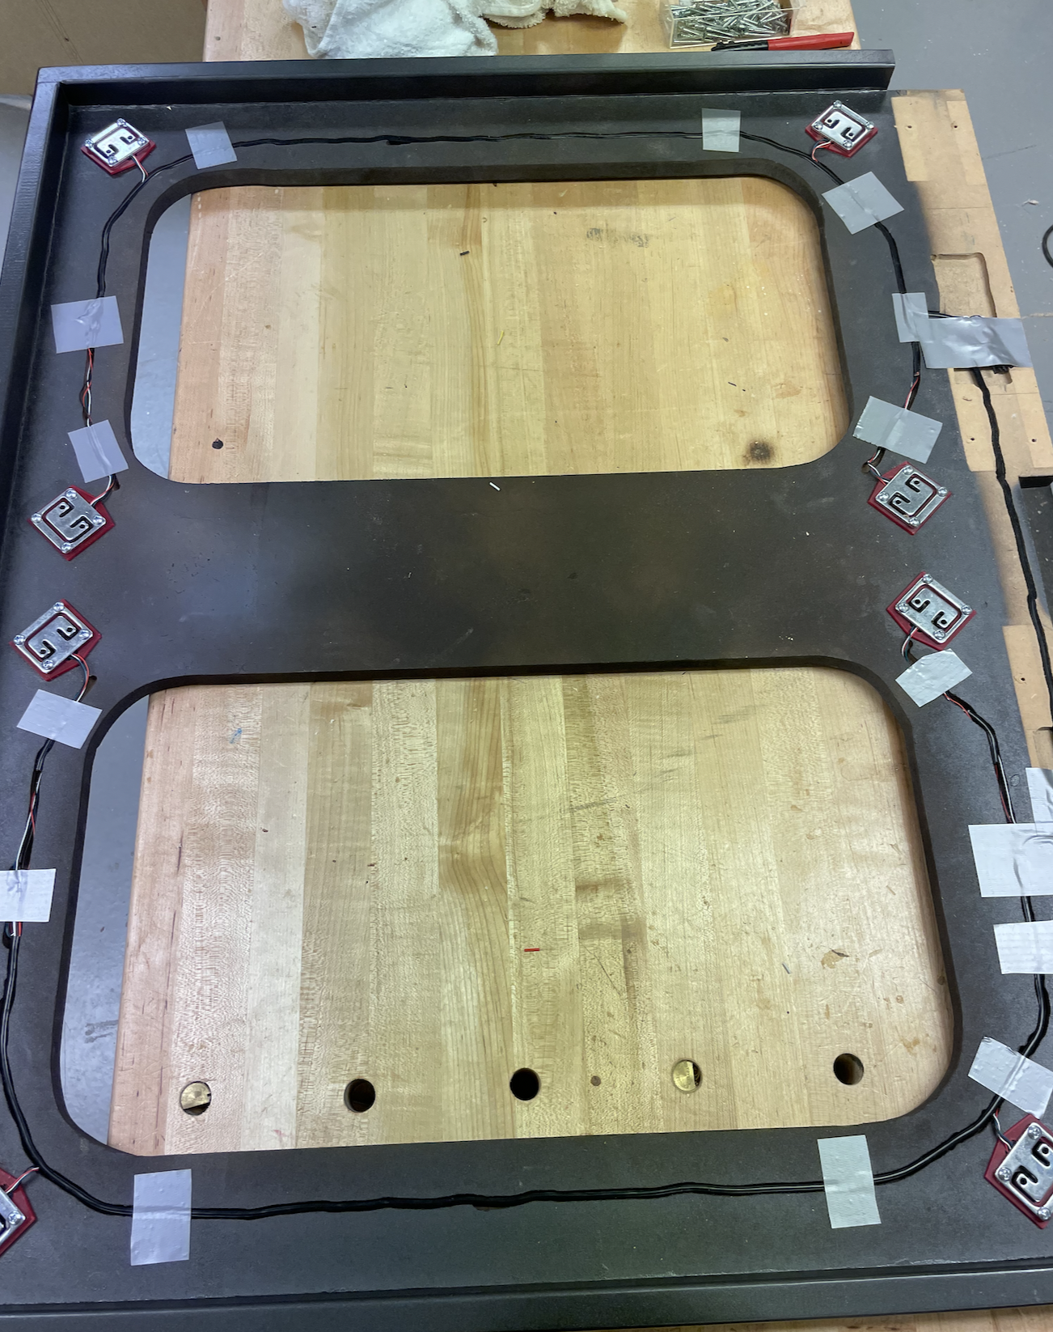

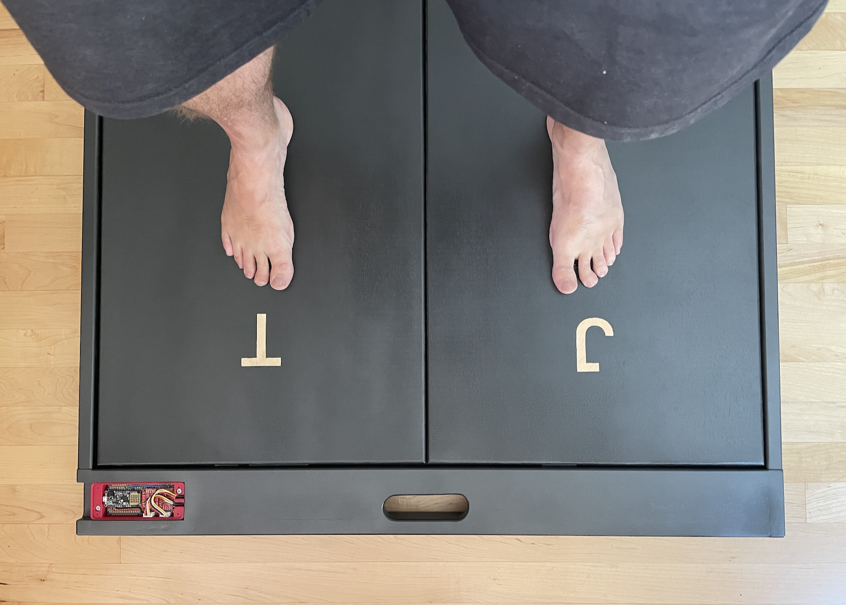

Dimensions of force plates – There is nothing magic about a specific number but the idea is to have something large enough that a person can jump and land on them “solidly in the center of the plates”. Each of these plates are 14” by by 28”.

Tools utilized to build jump plates

* Table saw
* Drill and Impact Driver
* Misc. hand tools
* Jigsaw
* Router ¼” with straight bit (for cable routing) and 1/8” round over bit (all corners)
* Sandpaper and paint if desired

Force Plate Wiring Diagram (note: blue wire might be green):

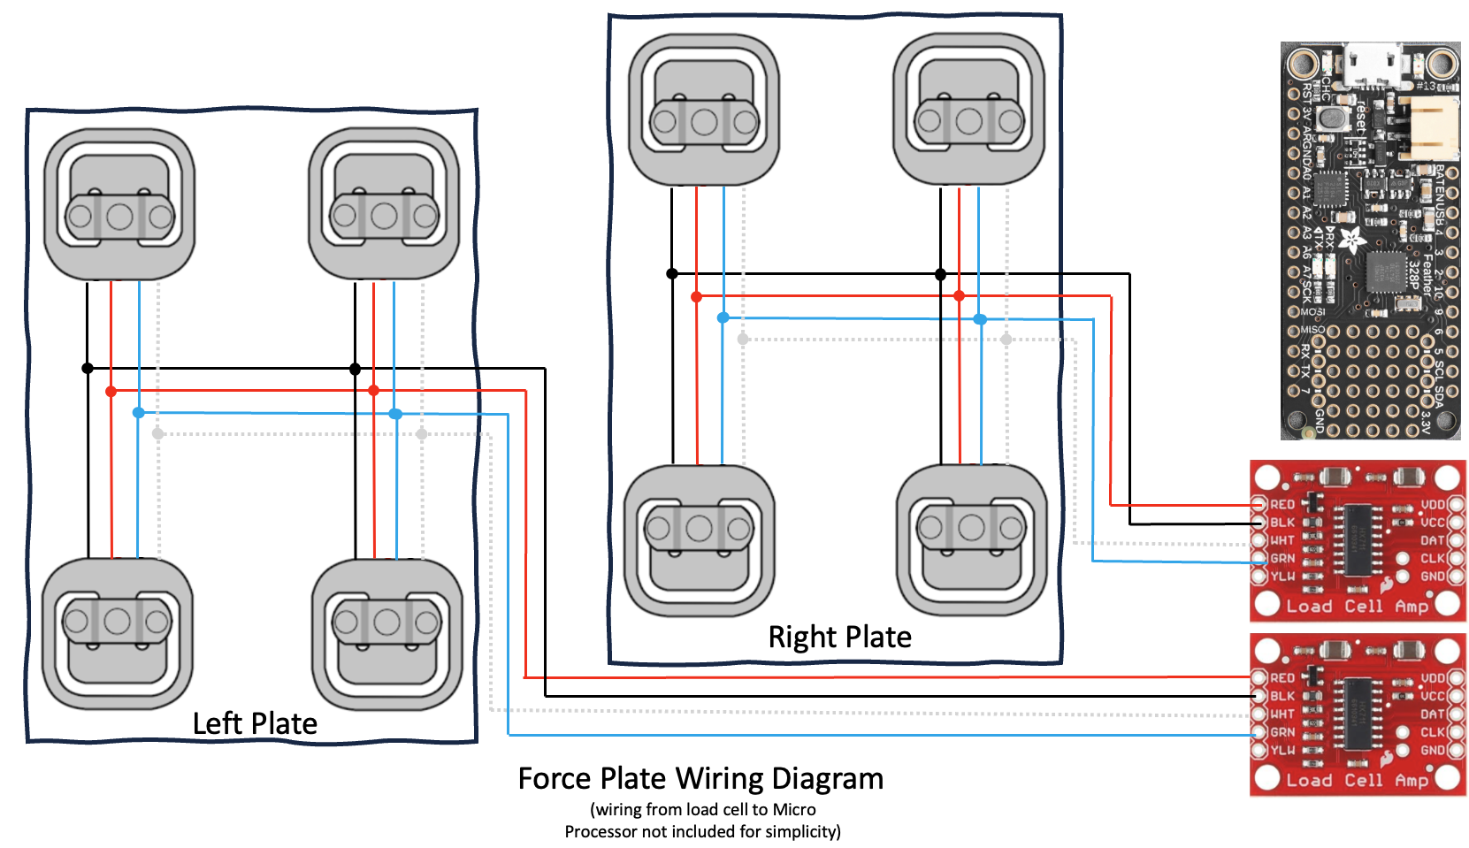

The details:

* Load Cells are equivalent to a strain gauge for purposes of this document – the concept of these has been around for many years and technically a load cell is made up of 4 strain gauges known as a Wheatstone Bridge (see below).
* The jump plates in the photos have a 1/8” gap all of the way around them as it is critical that the force plates don’t touch each other or the sides.
* The load cells were put at a 45 degree angle in the jump plates shown above. I am not sure that was worth the effort and complexity. For another set, I would just have them face North/South and call it good.
* Notice that the base has a whole cut int the plates. This was done to reduce the weight of them but was not worth the effort. If the hole there. then all wires from the load cells can go diagonally to the center of the plate and make the wiring much simpler. I would highly recommend that!
* A ¼” straight router bit as utilized to create channels for the wiring. This was done free hand on purpose so that they channels were not straight. This helps keep the wires in place as it gives a friction fit. Additionally, some duct tape was utilized to hold wires in place
* The force plate sensor wires all end up in in two cables. One for the left leg and one for the right leg. Hopefully it is obvious that 4 sensors on one piece of Baltic Burch plywood make up one of the “scales” or plates, ditto for the other plate. Wiring the 4 sensors should have all like colors combined (ie, in parallel). See Force Plate Wiring Diagram above.
* The “Left” force plate cable needs to arrive at the furthest amplifier away from the micro controller. This was shown earlier in the wiring diagrams. The picture here shows the disconnect (which are optional): 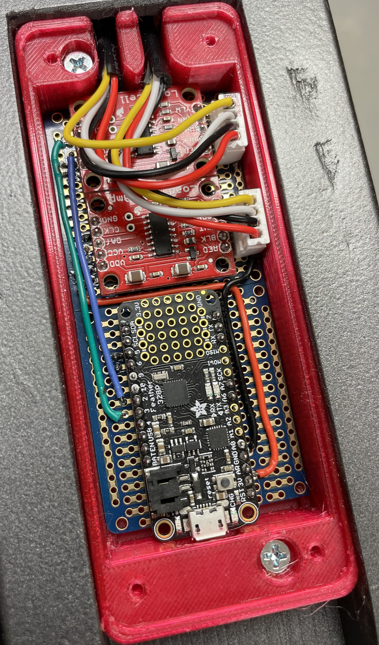
* For the force plate sensors, the wiring gets a little funky as the ¼” cable doesn’t have a blue/green wire but instead has yellow wire. Utilize the table below to keep things straight:

|  |  |  |
| --- | --- | --- |
| Sensor wire color | Cable color | Sparkfun HX 711 load cell |
| red | red | RED |
| black | black | BLK |
| white | white | WHT |
| blue or green | Yellow (that is how it comes) | GRN |
| n/a | n/a | YLW not used |

* Please note that the YLW connection on the Sparkfun HX711 is not utilized for the Force plates.
* Last note on wiring: if you look through the photos there is a lot of wiring going around, the bigger ¼” cables are easy to work with, the wires from the load cells/strain gauges are very thin and can be difficult to work with. See photo below and notice that there needs to be place for all the wires to and be soldered together in your design of the plates.
* Actual wiring where there is a lot going on: 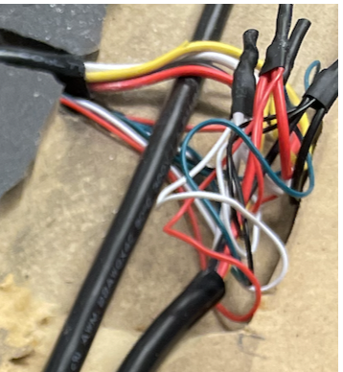
* The little “stand offs” (see BOM, 8 bottoms, and 8 U shaped tops) are designed so that the load cells have some room to flex while being jumped on. In the photos you can see the larger standoff goes on the bottom and smaller one goes on top of the load cells. These are probably the most complex part of the force plate assembly. The four screws that go down are obvious but before the plates are screwed down, Two ½” diameter holes needs to be drilled in the “base board” so that the 2 screws can be driven up into the bottom of the actual jump plate. This is further complicated by the fact that the jump plate needs to have ½” diameter holes drilled 1/8” deep for “relief” for the head of the 4 screws that hold the load cell down. IE, the jump plate should not be resting on the 4 screws that hold the load cell down. A smart guy would have said make the plastic U-Shape thicker to avoid this last step. I was concerned the standoff might get too thick and create other problems. If you chose to go this route, of utilize 2 of the U-shaped standoffs stacked. You might need to increase the screw length from ¾” to 1”.
* 3D Printing the Offsets. As is the cases described above the Offsets are 3D printed from the MK3 file here. Offsets should be printed in PETG and they should have 100% Infill.
* It is left up to yourself how to build the wiring channels shown in the photos above. This applies to the micro-controller plastic box as well.
* Lastly, “feet” are glued onto the bottom of the baseboard to help level it. The feet should be right under the load cells. The feet on these were 2” squares, 1/8” thick. They had holes drilled in them so that the 2 screws could be inserted to hold the force plate on.

# Technical FAQ:

1. Will TPC Analytics run on Windows?
   1. The software was largely developed and does run on Windows. The problems on Windows are as follows:
      1. Video Camera doesn’t work - The Python CV2 library has a many second lag (~45 seconds) to bring up the video camera essentially making it useless. Maybe I was doing something wrong, but this feature does not work until the issues are figured out.
      2. Lose past calibration of sensors - Each time the sensors are calibrated they are stored under the name of the COM port. For Windows this was typically COM3. When moving between the Jump Plate Micro Controller and ISO Leg Extension Micro Controller there is no way for the software to know which one it is communicating with. IE, the user will have to calibrate each time they switch from one to the other. This is not the end of the world, but this is not an issue with the MAC
      3. No installation procedure – Because the target users were on the MAC, the time to create and validate the installation procedure for Windows was not done. I suspect with not too much work the MAC install could be modified to provide a very similar installation on Windows.
2. What Hz are the load cell sensors running at?
   1. The Sparkfun HX711 load cell amplifiers run at about 73 Hz in practice. While this is not anywhere near of the speed of commercial Jump Plates it is still very fast for the amount of $’s for this setup. I did look for other load cell amplifiers that operate faster but didn’t come up with an obvious solution. The software as currently setup should be able to handle 500 Hz with no problems. Currently, the USB port is running at 115200 baud rate which could be increased as well
3. What is the FPS for the camera?
   1. The camera is supposed to be capable of 60Hz but I learned after purchase that the macOS is only supported at 30Hz which is where this setup operates. I did not try for 60Hz on Windows because of other issues (see Windows FAQ).
4. Why does the “toe off” in the data graph not line up exactly with the video?
   1. I was never able to perfectly sync the start of reading measurements and the start of the Video recording. Having been unable to do so, I finally accepted that the next best which was to allow the user to “align the video to graphic showing the forces”. This is easiest by setting the force at its minimum just as the jumper leaves the force plate. Then utilize the alignment slider to put the athletes toes just leaving the jump plate “toe off”. Then as the main video slider is moved back and forth the athlete is in the correct position relative to the actual forces being applied.
5. Can I change or modify the code?
   1. The Code is provided via the GNU public licensing agreement. Essentially this gives anybody the right to modify the code so long as they make the modifications available publicly via GitHub. This also applies to any person/company that wants to utilize the code commercially.
6. What language was TPC Analytics written in? Python code utilizing PyCharm, the interface libraries are PYQT6. CV2 for video and PySerial were also utilized. Check the requirements.txt for all required modules.
7. What is a Wheatstone Bridge?
   1. A typical Wheatstone bridge in load cell applications is made up of four load cells. Load cells were historically call strain gauges which is essentially an electrical resister glued to a material like steel or aluminum. This arrangement allows for precise measurement of mechanical load. The four load cells are connected in a way that balances the bridge, making the system sensitive to the applied load while compensating for temperature and other environmental factors. This configuration is commonly used in industrial scales and precision measurement tools due to its accuracy and reliability.

# Useful Links:

Links that might

To see current BOM with active links go here. The following is snapshot as of 1/28/2024 to give a flavor:

